Compatability modifying in internet explorer(i.e)

Open ie---click on gear icon right side corner---compatability view settings--🡪

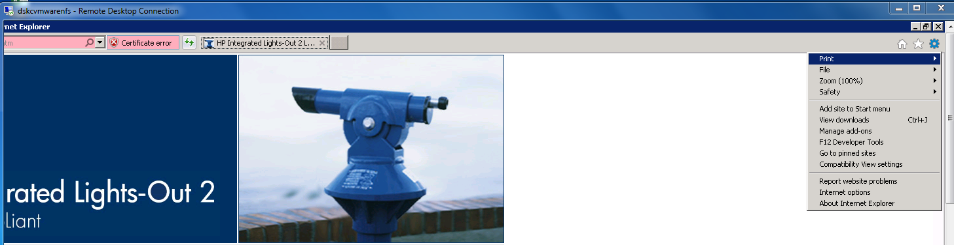

Add your website here either ip or url

